**Client Name:** iConsultancy Program, University of Maryland  
**Team Name:** Project Portfolio Management Team  
**Team Members:** Siya Patel, Ishita Singh, Tyreek Hood, Evan Schneider, Bruce Wyatt

Documentation For Project Portfolio Management

This is documentation for the beginning stages of a Project Portfolio Management dashboard that could be hosted by iConsultancy at a later time. For now, we are using Excel and Tableau to make the potential visuals we are looking for in the dashboard to allow for better project management.

1. JIRA data can be exported by going to the side panel on the left and moving to “All issues” Once there, on the top right of the page there will be an Export button where Export CSV can be found.

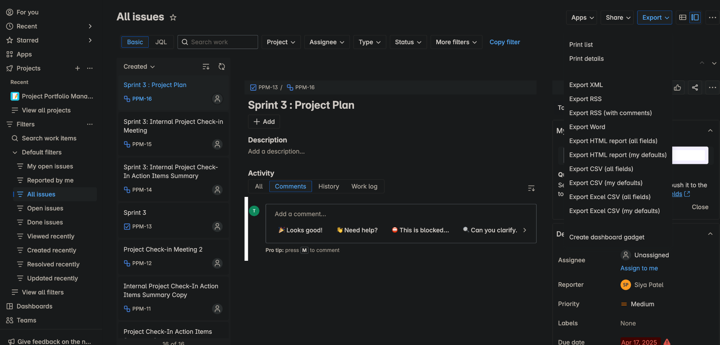

1. The user will input relevant data into the Excel sheet. Whether it’s creating a new table for a new group or updating an existing table. The most important columns are the following:
   1. Task
   2. Issue Key
   3. Issue Type
   4. Status
   5. Project name
   6. Assignee
   7. Priority
   8. Created
   9. Due date

Other data can be removed from the table if desired.

1. When all data is input, data visualization can now be created using Tableau after downloading the Excel file that has been properly cleaned. Connect to a file selecting Microsoft Excel.

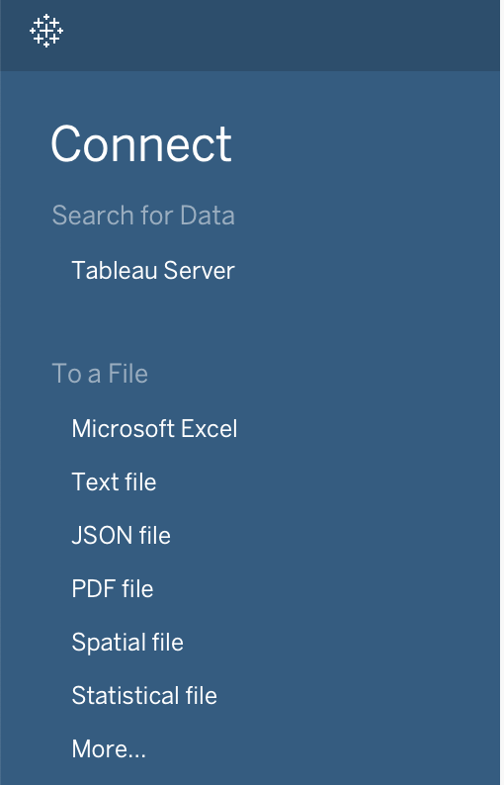

5. Once imported, depending on whether there are multiple sheets in the Excel file, select the desired sheet and drag it from the side panel on the left to the actual window.

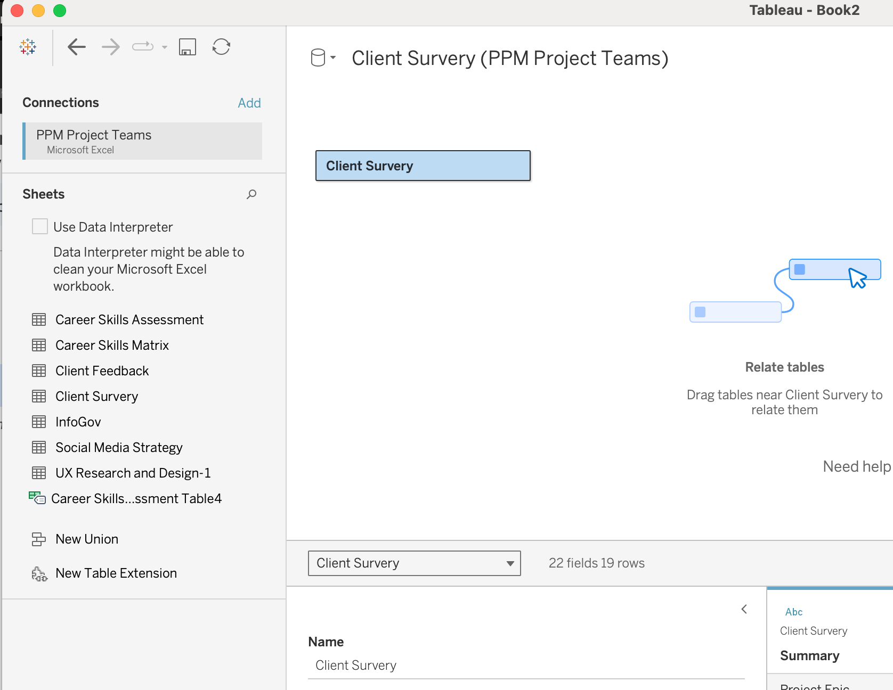

6. The data is now ready to be manipulated, on the bottom of the application, move to Sheet 1. There must be at least one table under Rows and one under Column to begin creating visuals. Now the user can try different visuals and tables to use how they see fit.

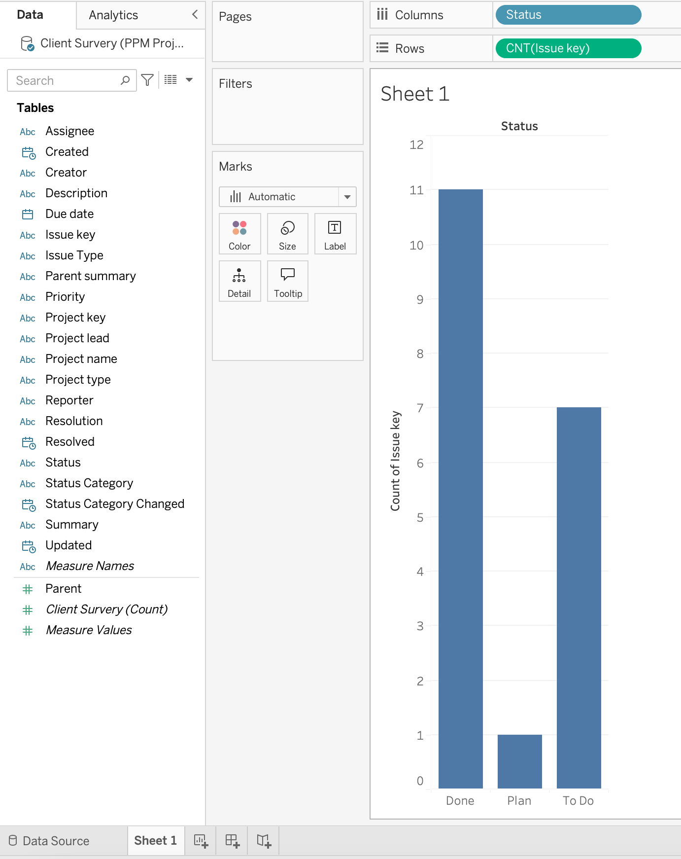

The current business model is as such:   
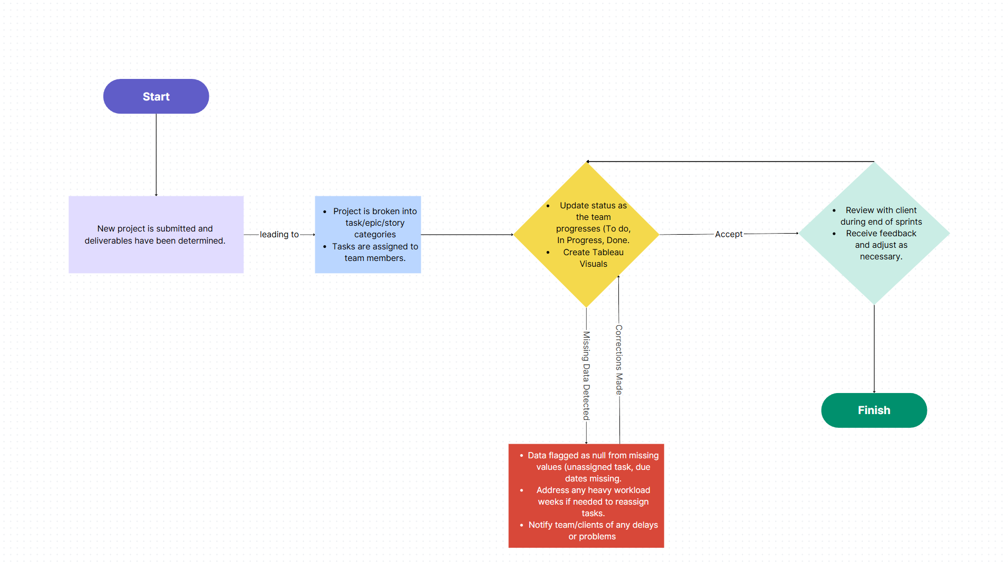

When there are null values inside Tableau, it is a flag that there are missing data points inside a table. Once the value is filled, the null value(s) should be gone and it can be removed from the graph. An example of this would be here:

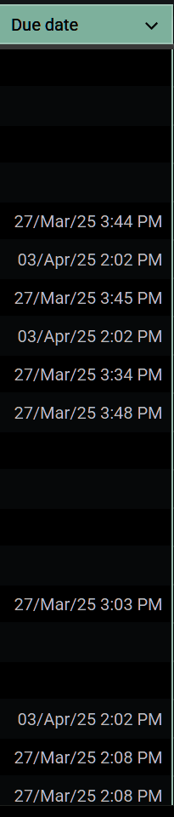

In Career Skills Matrix, we have missing due dates and it shows in the Due Date heatmap visual below: 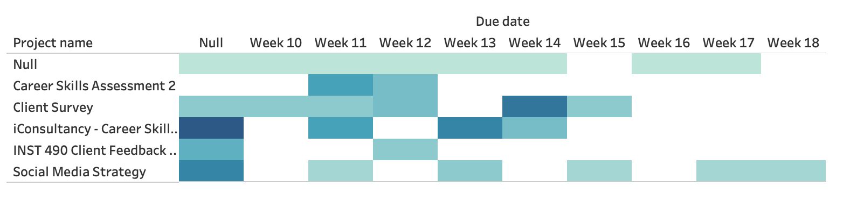

Null values are undesired and should be kept to a minimum to not convolute the data and keep it as accurate as possible. The visuals will help users realize data is missing and needs to be properly adjusted.